SFY 2022-2023 Youth Problem Gambling Awareness and Prevention
Program (YGAP) Implementation Plan for Stacked Deck Curriculum
School/Community-Based Program: |  |  |  | Date:
Physical Address: |  |  |  | County:
City: | State: |  | Zip: | Phone:
Website: |  |  | Social Media/Website:
Grant Contacts |  | Phone |  | Email
Principal or Director:
Grant Coordinator:
Stacked Deck Instructor #1:
Stacked Deck Instructor #2:
Please list all other Stacked Deck instructors at the school who will be teaching the curriculum. All instructors must be trained on the curriculum to teach. The grant coordinator is the person responsible for writing the grant and reporting outcomes. Grant checks will be mailed directly to the school. Please provide all information below.

Make Checks Payable to:
Mailing Address: Attention:
SFY 2022-2023 Youth Problem Gambling Awareness Program

School/Community-based Program: Which semester will the program be implemented?:
Does your school have a Title I designation? Yes No
Is this the first year your organization has applied for this grant? Yes No
Has your organization applied for the grant in the last five years? Yes No
Does your school or organization serve students with families in the military? Yes No If yes, in what county?:
What is the percentage of the student population who is on free lunch or reduced lunch?:
Proposed Programs | Outcomes (What are the activities you will  implement and how many people?) | Measures  (How will you measure your success?)
Implement all six lessons of the Stacked Deck curriculum by utilizing the PowerPoint and all accompanying handouts to increase awareness of problem gambling among students.

Or

Implement all seven self-paced learning modules utilizing the learning management system. All lessons must be delivered in the classroom.
Proposed Programs | Outcomes (What are the activities you will  implement and how many people?) | Measures  (How will you measure your success?)
Increase general outreach, prevention and awareness about problem gambling in the school or community by implementing an outreach activity.

SFY 2022-2023 Problem Gambling Outreach/Prevention/Awareness Budget

School/Organization: Total projected funding available for SFY 2022-2023:
Budget Category | Budget Amount | Budget Narrative (Please describe expenses)
Program Costs (the number of hours preparing and teaching curriculum and implementing outreach, equipment purchases, teacher supplies, contractors and program supplies)
Other (be specific)
TOTAL

Sample Proposed Program | Sample Outcomes | Sample Measures
Implement all six lessons of the Stacked Deck curriculum by utilizing the PowerPoint and all accompanying handouts to increase awareness of problem gambling among students.  Or  Implement all seven lessons utilizing the learning management system. All students must have access to a device and all lessons must be delivered in the classroom. | - Utilize the PowerPoint Presentation and teach the Stacked Deck curriculum to 9th grade students. This is the entire grade.  - Utilize the self-paced learning modules in the learning management system and present the curriculum to 9th grade students. This is the entire grade.  - Available for fidelity check, feedback, training and technical assistance during the year from NCPGP Prevention Coordinator. | - Using pre- and post-tests, (percentage of students) of participants will demonstrate knowledge in problem gambling after taking curriculum.  - staff will receive training on curriculum in the 2022-2023 FY.
Increase general outreach, prevention and awareness about problem gambling in the school or community by implementing an outreach activity. | - Send out a press release to recognize Problem Gambling Awareness Month (March)  - Develop a poster competition in the area of problem gambling. Winning posters will be placed in hallway and on school website.  - Develop a PSA and distribute on school website and school news station.  - Helpline brochures and posters will be available to students in the front office. | - Press release will reach community members based on readership of publication.  - Wining posters will reach at least students based on number of students in school. It will also reach at least parents based on website visits.  - The PSA will reach at least based on number of clicks on school’s website and based on school population for the school news station.  - Helpline brochures and posters will be available to students in location(s).
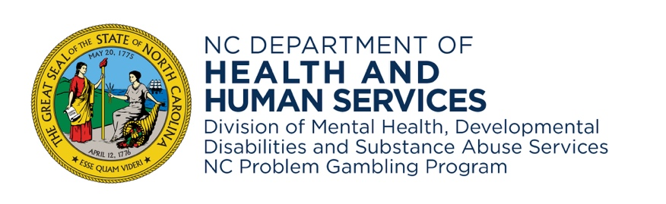
morethanagame.nc.gov • NCDHHS is an equal opportunity employer and provider. • 5/2022

